Task – 16/09/2020

**Task : 2-way binding**

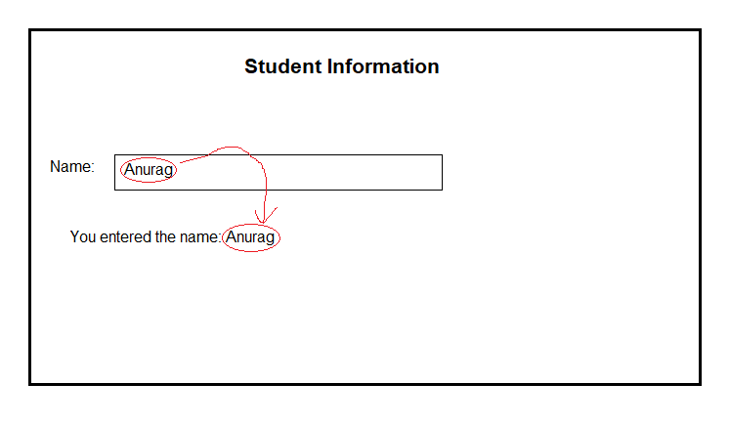

app.module.ts

--------------------------------------------------------------------------------------------------------------------------------------

import { FormsModule } from '@angular/forms';

imports: [FormsModule]

--------------------------------------------------------------------------------------------------------------------------------------

app.component.ts

--------------------------------------------------------------------------------------------------------------------------------------

import { Component } from '@angular/core';

import { FormsModule } from '@angular/forms';

@Component({

  selector: 'app-root',

  templateUrl: './app.component.html',

  styleUrls: ['./app.component.css']

})

export class AppComponent {

  textvalue:string;

title = 'testproject1';

}

--------------------------------------------------------------------------------------------------------------------------------------

app.component.html

--------------------------------------------------------------------------------------------------------------------------------------

<h4>Student Information</h4>

  Name : <input type="text"  [(ngModel)]="textvalue" />

<p>You have entered this Name: </p>{{textvalue}}

<button class="btn btn-success">Click</button>

--------------------------------------------------------------------------------------------------------------------------------------

**Task : User forms to show total marks and percentage. Use bootstrap classes for styling**

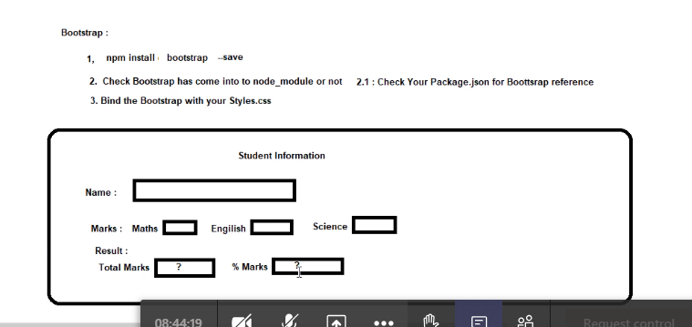

my-component.component.ts

--------------------------------------------------------------------------------------------------------------------------------------

import { Component, OnInit } from '@angular/core';

@Component({

  selector: 'app-my-component',

  templateUrl: './my-component.component.html',

  styleUrls: ['./my-component.component.css']

})

export class MyComponentComponent implements OnInit {

  mathsmarks:number;

  englishmarks:number;

  sciencemarks:number;

  constructor() { }

  ngOnInit(): void {

  }

}

--------------------------------------------------------------------------------------------------------------------------------------

my-component.component.html

--------------------------------------------------------------------------------------------------------------------------------------

    <h4>Student Infomation</h4>

    <div class="form-group form-inline">

    <p>Name: &nbsp; <input type="text" class="form-control"  placeholder="Enter your name..."></p>

    </div>

    <div class="form-group form-inline">

        <p>

            Marks:&nbsp;&nbsp;&nbsp;&nbsp;&nbsp;&nbsp;

            Maths&nbsp;<input type="number" class="form-control" [(ngModel)]="mathsmarks" placeholder="Enter maths marks..."/>

            &nbsp;&nbsp;&nbsp;

            English&nbsp;<input type="number" class="form-control" [(ngModel)]="englishmarks" placeholder="Enter english marks..."/>

            &nbsp;&nbsp;&nbsp;

            Science&nbsp;<input type="number" class="form-control" [(ngModel)]="sciencemarks" placeholder="Enter science marks"/>

        </p>

    </div>

    <div>

        <p>Result:</p>

    </div>

    <div class="form-group form-inline">

        <p>Total marks: &nbsp;<input type="number" class="form-control" value="{{mathsmarks+englishmarks+sciencemarks}}">&nbsp;&nbsp;&nbsp;%Marks: &nbsp;<input type="number" class="form-control" value="{{(mathsmarks+englishmarks+sciencemarks)/3}}"></p>

    </div>

--------------------------------------------------------------------------------------------------------------------------------------